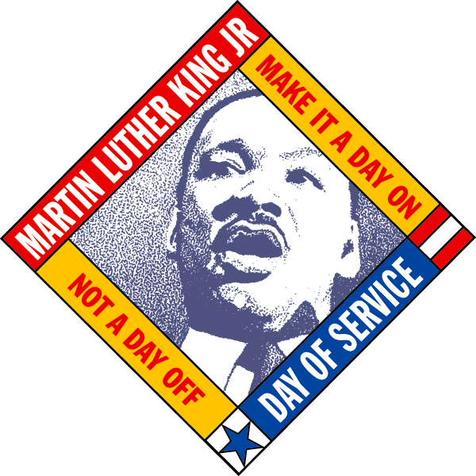

MARTIN LUTHER KING, JR. YOUTH SERVICE DAY
JANUARY 15, 2018
Meet at Georgetown Teen Center 9:00 A.M.

The Georgetown Project invites youth, grades 9-12, to join us for 2018 MLK, Jr. Youth Service Day! Just show up at the Georgetown Teen Center, located on the north end of the Georgetown Recreation Center at 1003 N. Austin Avenue, at 9:00 a.m. on January 15. Free pizza lunch provided by The Georgetown Project. Youth will receive 4 hours of service credit for the event.

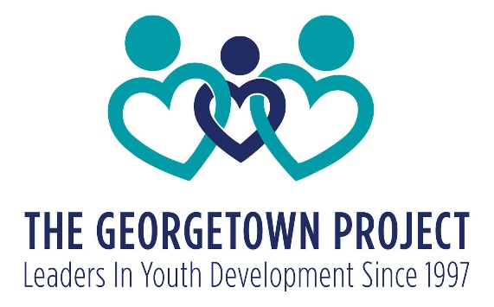

Service Projects:
MLK Youth Service Day Schedule:

9:00—9:30 am
Meet & Greet At Teen Center
Sign Up For Projects
MLK Day Presentation

9:30 am—12:30 pm
Service Projects

12:30—1:00 pm
Free Pizza Lunch—Service Certificates Available

1. Park Place Senior Center (games/projects with residents-indoors)
2. Georgetown Parks & Recreation (park clean up-outdoors)
3. The Georgetown Project Home Office (window cleaning/landscaping-outdoors)
4. The Georgetown Project NEST Empowerment Center (indoor and outdoor projects)
5. Willie Hall Center (painting/landscaping-outdoors)
6. Habitat ReStore (organizing/stocking-indoors)—must be 18 for this project
7. Southwestern University (making blankets for kids in need-indoor project)

You must provide your own transportation to and from the Teen Center; transportation to/from the service site will be provided for certain projects not in walking distance.

For more Information, please contact The Georgetown Project: (512) 943-0074
www.georgetownproject.org

